**Aim:- Import the legacy data from different sources such as (Excel,CSV,Odata etc.) and load in the target system.**

1. **Importing Excel Data**
2. **Launch Power BI Desktop.**
3. **From the Home ribbon, select Get Data. Excel is one of the Most Common data**

**connections, so you can select it directly from the Get Data menu.**

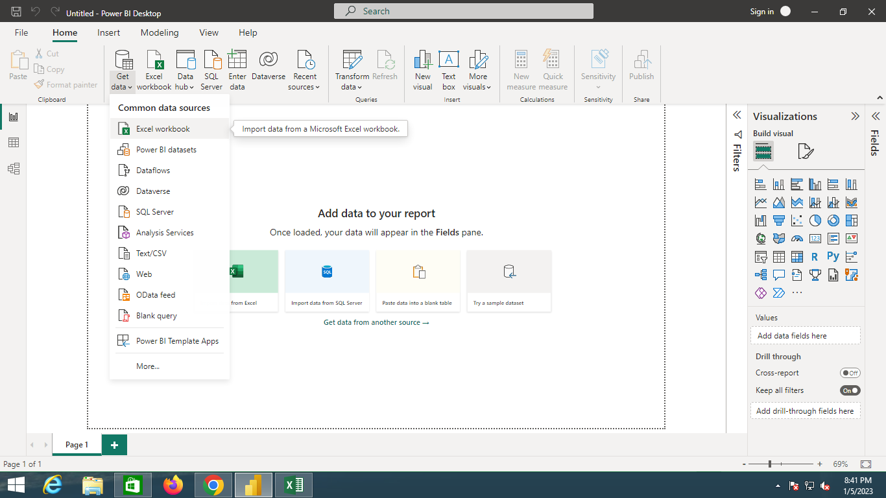

1. **If you select the Get Data button directly, you can also select FIle > Excel and select**

**Connect.**

1. **In the Open File dialog box, select the Products.xlsx file.**
2. **In the Navigator pane, select the Products table and then select Edit.**

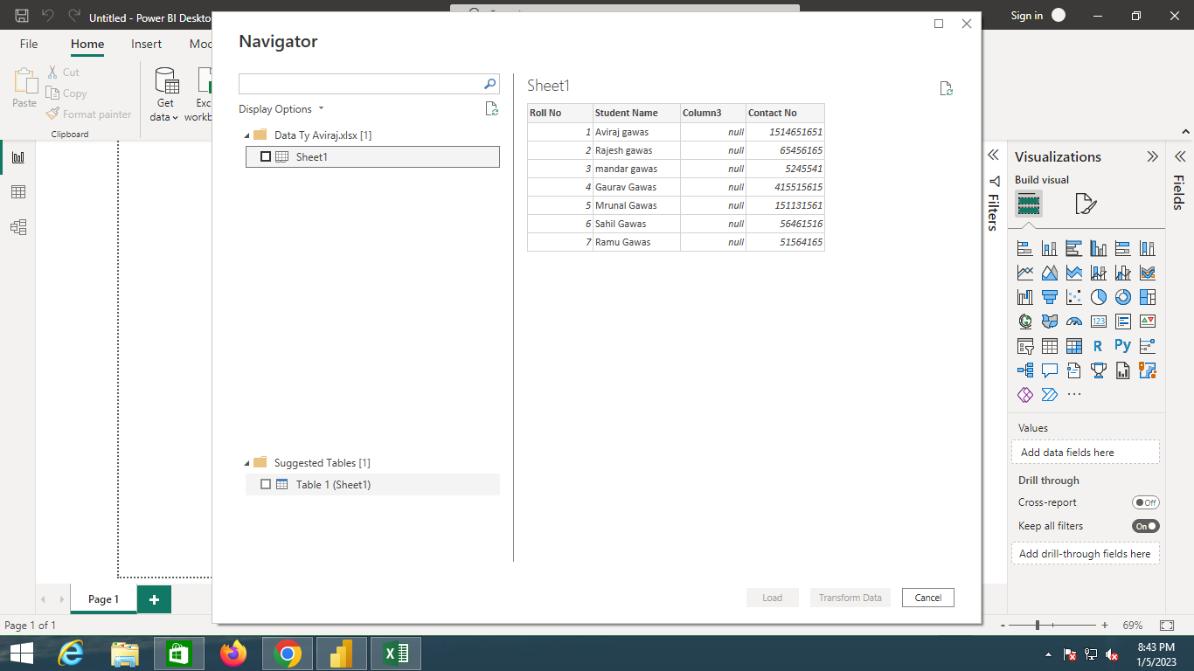

1. **Check The Checkbox.**

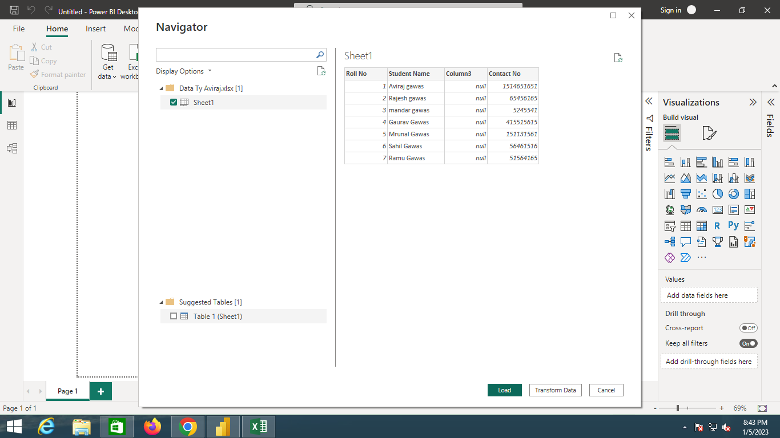

1. **Click On Load.**

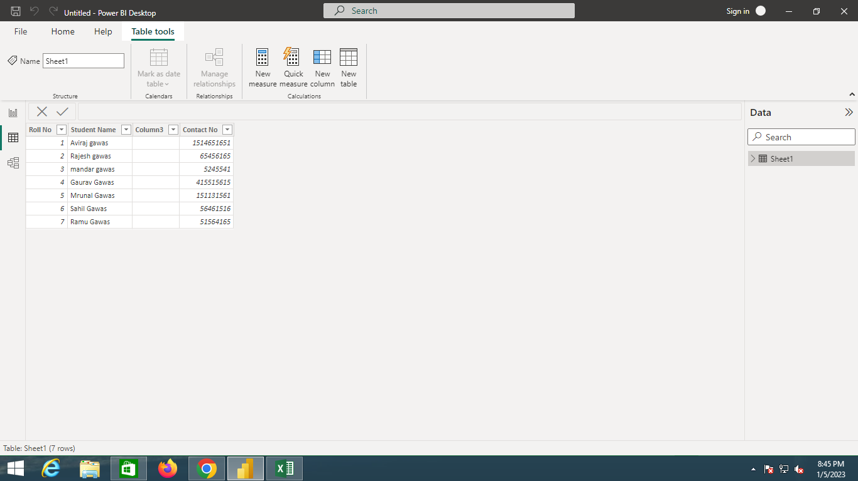

1. **Importing CSV Data.**
2. **Open Csv Data File.**

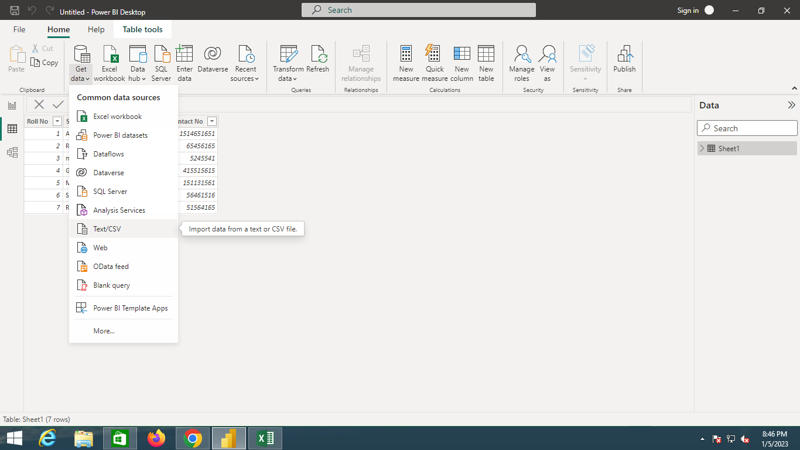

1. **Import CSV File and Click Open.**

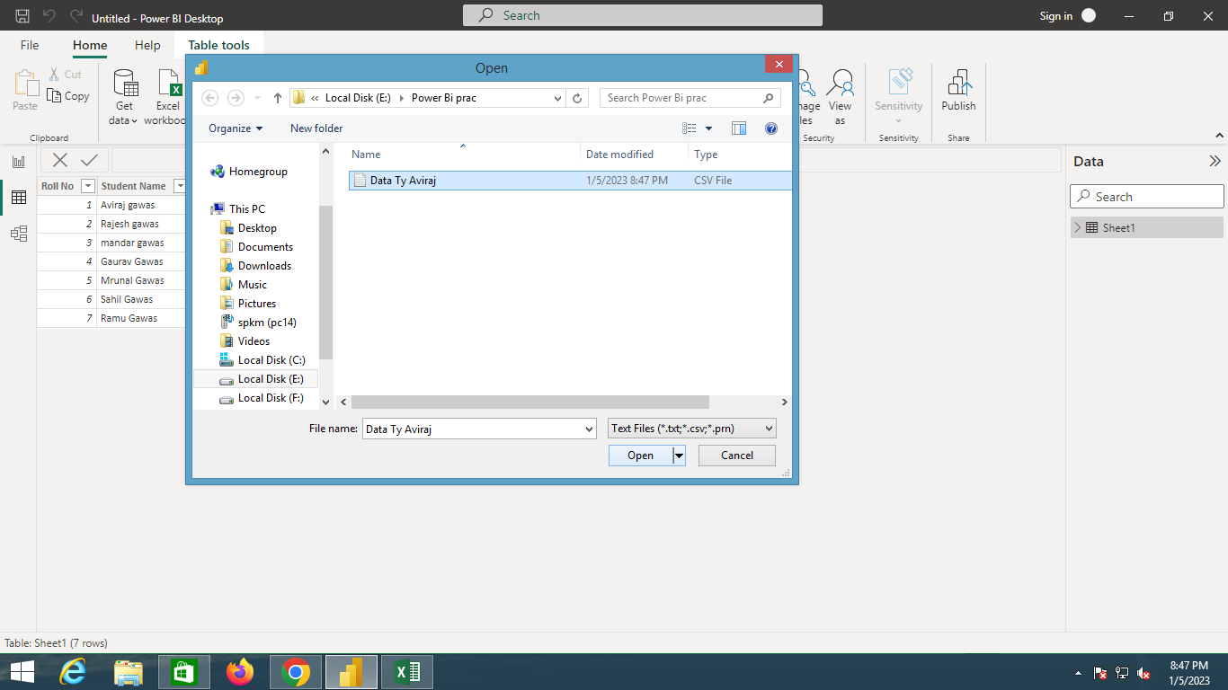

1. **Click On Load Button.**

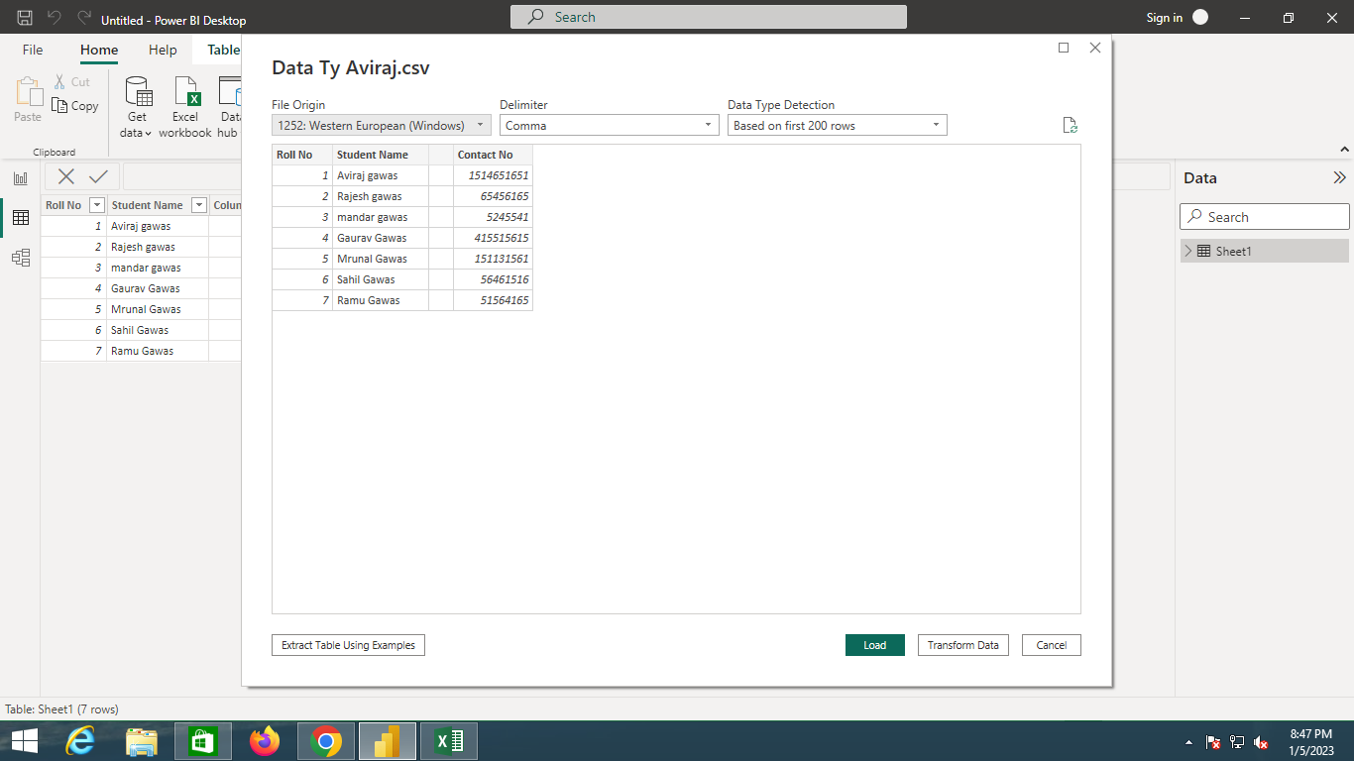

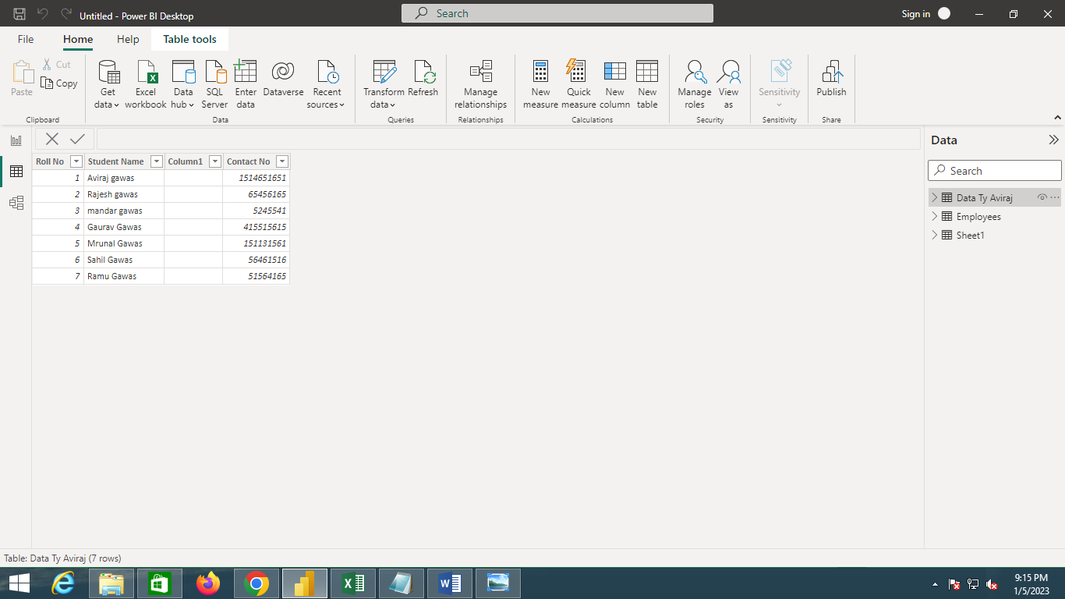

1. **Importing O Data Feed.**
2. **Open O Data Feed.**

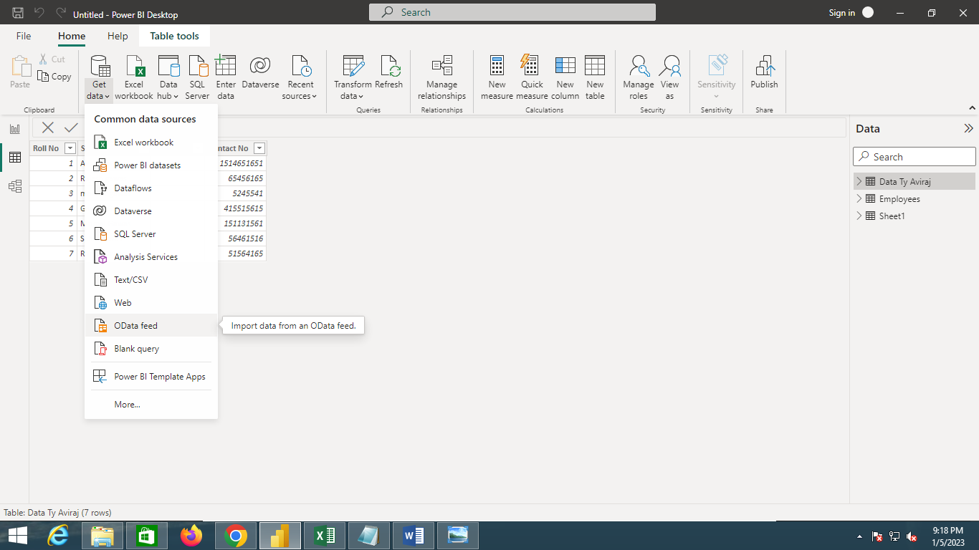

1. **Browse to the OData Feed data source.**
2. **In the OData Feed dialog box, paste the URL for the Northwind OData feed.**
3. **Paste This URL http://services.odata.org/V3/Northwind/Northwind.svc/**

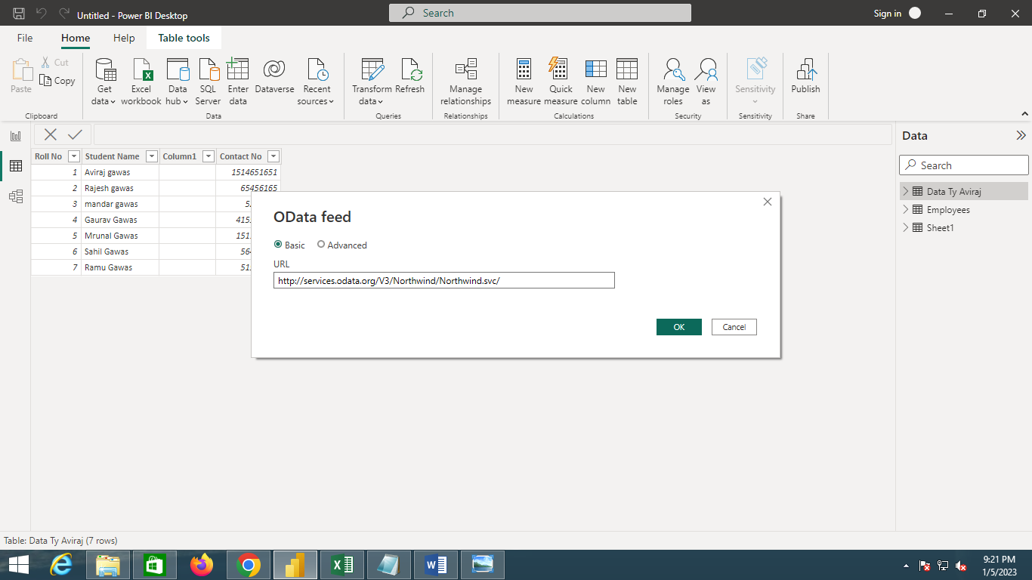

1. **Select OK.**
2. **In the Navigator pane, select the Orders table, and then select Edit.**

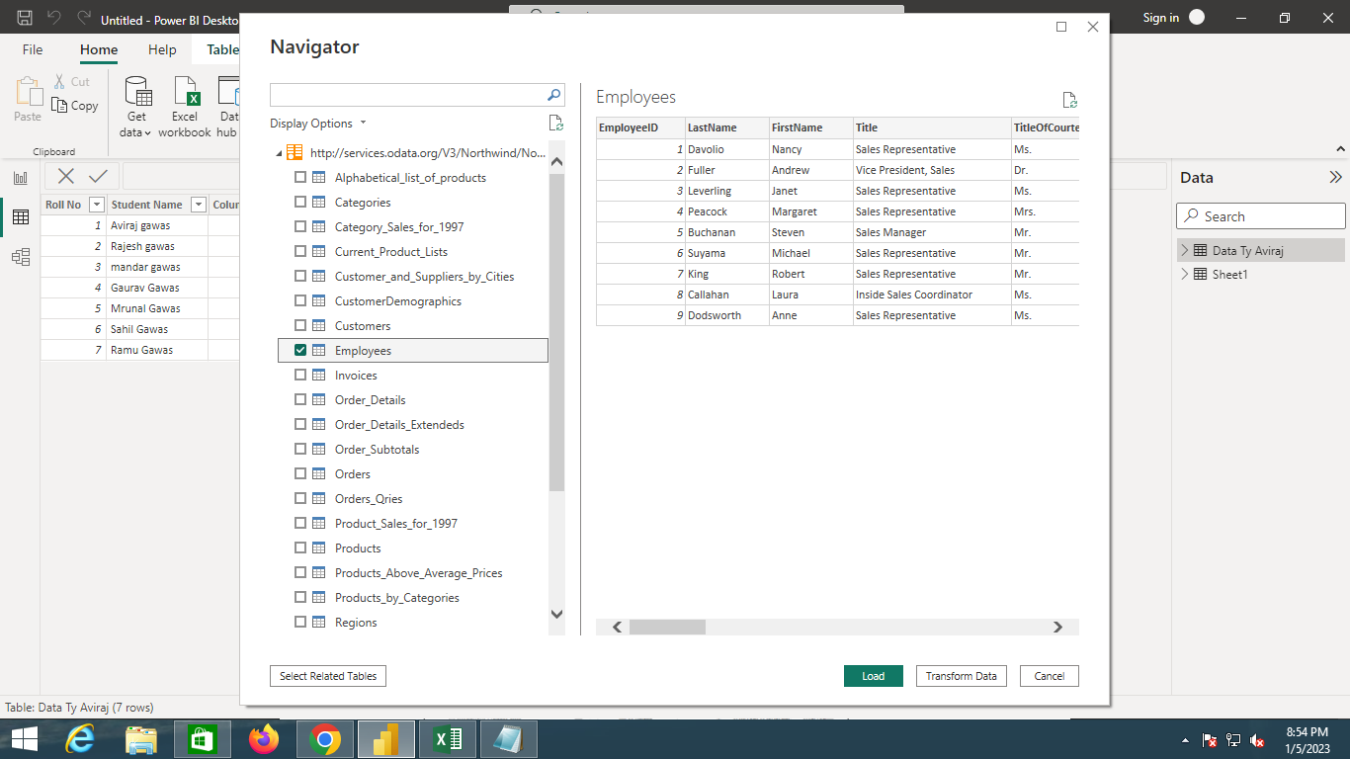

1. **Select Load.**

